Students Name: …………………………………………………………………
School Name:…………………………………… Index Number ……………
P530/1
BIOLOGY
PAPER 1
THEORY
JULY/AUG 2023
2 ½ Hours

HES INTERNAL MOCK EXAMINATIONS 2023
UGANDA ADVANCED CERTIFICATE OF EDUCATION
BIOLOGY
PAPER 1
2 HOURS 30 MINUTES
INSTRUCTIONS:
- This paper consists of 40 questions in section A and 6 questions in section B.
- Answer all questions in both sections A and B
- Section A: Answers to this section must be written in the boxes provided.
- Section B: Answers to this section should be written in the spaces provided and not anywhere else.
- No additional sheet(s) of paper should be inserted in this booklet.
For Examiner’s Use only
SECTION | MARKS | INITIALS
Section A: 1-40
Section B: 41
42
43
44
45
TOTAL

SECTION A (40 MARKS)

1. During respiration in the absence of oxygen, pyruvic acids is converted into:
A. lactic acid and carbon dioxide in animals.
B. lactic acid and water in animals.
C. ethanol and water in plants.
D. ethanol and carbon dioxide in plants.
2. Lignification of plant cells has the effect of:
A. widening the cells and making them move permeable.
B. making the cells more rigid and killing them.
C. making the cells impermeable and lengthening them.
D. strengthening the cells and making them more permeable.

3. The following apply to a population which is rapidly growing except;
A. reproduction rate is higher than death rate.
B. absence of predators.
C. absence of competition.
D. shortage of reproducing individuals.

4. Which one of the following sets of conditions in the guard cells would lead to the opening of stomata?
A. High carbon dioxide concentration and low sugar concentration.
B. Low carbon dioxide concentration and high sugar concentration.
C. High sugar concentration and high carbon dioxide concentration..
D. Low pH and high starch concentration.

5. In which one of the following is the respiratory quotient most likely to be lowest?
A. During lactic acid formation in animals.
B. In plants during bright light.
C. In animals during laying down of fat.
D. During egg laying in birds.

6. When a DNA sample was analysed, it showed that 28% of the bases were adenine. The percentage of cytosine therefore is
- 36.
- 16.
C. 28.
D. 22.

- Which one of the following does not result from the effect of gibberellins?
- Internode elongation.
- Seeds germinate.
- Buds spout.
- Senescence occurs.

8. The following are events occurring during transmission of an action potential except;
- Inside of the membrane becomes more positive than outside.
- ${Na}^{+}$ channels open, ${Na}^{+}$ rush in.
- ${Na}^{+}$ and $K^{+}$ channels close.
- Membrane is more permeable to ${Na}^{+}$.

9. Which one of the following is not a response to high blood glucose level?
- Increased glucose oxidation.
- Increased glucose production.
- Increased insulin production.
- Increased glycogen levels.
10. Migratory fishes in salty water overcome the problem of low water potential in their body by;
- swallowing large volumes of fresh water.
- swallowing large volumes of salty water.
- actively pumping ions into their blood via gills.
- actively secreting salts through gills out and releasing large volumes of water through gills.

11. The following are products of non-cyclic photophosphorylation except;
- $NADPH$.
- $NADP^{+}$.
- $ATP$.
- $O_{2}$.

12. Which one of the following statements does not support the evolutionary
significance of glycolysis?
- Bacterial fossils date before accumulation of oxygen in the atmosphere.
- Glycolysis does not require membrane bound organelles.
- Glycolysis yields less ATP sufficient for prokaryotes.
- Glycolysis is the most wide spread metabolic pathway.

13. Which one of the following magnifications would enable you to see the largest surface area of a specimen under a microscope?
A: X40
B: X100
C: X400
D: X1000

14. The cell wall of nitrosomonas is made up of
A: capsule

B: peptidoglycan
C: cellulose
D: lignin

15. Which one of the following is the correct arrangement of microtubules in a cross section at the base of a flagellum
A: 9 + 2
B: 9 + 0
C: 9 + 4
D: 9 + 1

16. The cell organelle not bounded by a membrane is
A: ribosome
B: golgi apparatus
C: endoplasmic reticulum
D: mitochondrion

17. The figure below shows a transverse section through a muscle myofibril

Which one of the following regions does the section represent?
A. H - zone.
B. A - band.
C. I - band.
D. M - band.

18. The role played by chromatophore pigments in the survival of an organism is
A. cause rapid muscle contraction hence escaping enemies.
B. increase oxygen delivary to the contracting muscles.
C. cause organism’s colour change hence camouflage.
D. eliminate carbon dioxide from the respiring tissues to increase pH.

19. The non – enzymatic components of intestinal juice are secreted by the cells in the:
A. wall of illeum.
B. crypts of lieberkiin.
C. gastric glands.
D. brunner’s glands.

20. In which one of these insects is the wing beat frequency at the same rate as the impulse supply?
A. Fruit fly.
B. Housefly.
C. Moth.
D. Bee.
21. The following are functions of semen except;
- destruction of bacteria in the urethral truct.
- Neutralizing the acidic medium of the vagina.
- Activation of spermatozoa.
- Nourishing the sperms.

22. The hormone controlling ovulation and leuteal phase of human menstral cycle is:
A. oxytocin.
B. FSH.
C. luteinizing hormone.
D. oestrogen.

23. Which one of these makes carbon dioxide have the greatest influence on global warming?
A. Retains more heat.
B. Has a higher concentration in the atmosphere.
C. Stays longer in the atmosphere.
D. Has acidic properties.

24. Cyclic photophosphorylation is likely to be the only operating path way in a cell where there is:
A. high concentration of reduced NADP.
B. low concentration of oxidized NADP.
C. high concentration of oxidized NADP.
D. low concentration of reduced NADPH.

25. The type of locomotion in aquatic organisms where the entire body is thrown into motion is called
A. ostraciform.
B. anguilliform.
C. carangiform.
D. lateral drag.

26. Figure below shows the action of a cilium to cause movement.
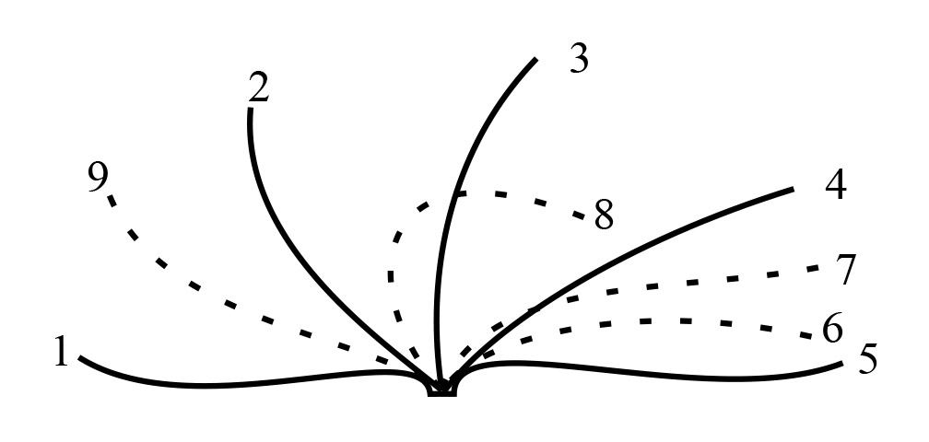
Which one of the following sets of positions represent passive stroke?
A. 1, 2, 3, 8.
B. 6, 7, 8, 9.
C. 1, 9, 4, 6.
D. 5, 7, 3, 2.

27. Heart sounds are due to;
- closure of values.
- contraction of cardiac muscle.
- opening of values.
- blood flowing.

- Which one of the following parts of leucocytes are most active during an infection?
- Lymphocytes and macrophages.
- Neutrophils and Eosinophils.
- Neutrophils and macrophages.
- Lymphocytes and Neutrophils.

- The amphibians in the arid conditions have solved their oesmoregulatory problems by;
- possession of long loop of Henle.
- having unique nocturnal habits.
- possessing few glomeruli.
- possessing water proof skin.

- Which one of the following cells is known for causing allergic reactions in the body of an organism?
- Basophils.
- Eosinophils.
C. Monocytes
D. Lymphocytes.

- Stretching of the vaginal tube during labour is made possible by the presence of;
- transitional epithelium.
- stratified epithelium.
- squamous epithelium.
- columnar epithelium.

- The following components are transported by the blood circulatory system in a cockroach except;
- oxygen.
- ecdyosone.
- uric acid.
D. glucose.

- The following conditions result from non-disjunction except;
- Klinefecter’s syndrome.

- Turner’s syndrome.
- Haemophilia.
- Down’s syndrome.

- If a cell has 46 chromosomes at the beginning meiosis, then at anaphase I there would be a total of
A. 23 chromatids
B. 23 chromosomes
C. 46 chromosomes
D. 46 chromatids

- All of the following statements are true EXCEPT:
A. Spindle fibers are composed largely of microtubules.
B. Centrioles consist of nine triplets of microtubules arranged in a circle.
C. All eukaryotic cells have centrioles.
D. All eukaryotic cells have a spindle apparatus.

- An mRNA actively being translated in the cytoplasm would have all of the following EXCEPT:
A. a poly-A tail
B. a 5' cap
C. exons
D. introns

- All viruses consist of
A. DNA and a protein coat
B. RNA and a protein coat
C. a nucleic acid and a protein coat
D. a nucleic acid and a phospholipid bilayer membrane

- In bacteria, a small circle of DNA found outside the main chromosome is called a
A. plasmid
B. cDNA
C. RFLP
D. PCR

- All of the following groups of organisms are photosynthetic EXCEPT:
A. cyanobacteria
B. diatoms
C. dinoflagellates
D. Foraminifera

40. A body cavity completely surrounded by tissue derived from the mesoderm that provides cushioning for internal organs is called
A. an archenteron
B. a coelom
C. a pseudocoelom
D. a gastrovascular cavity

SECTION B ([60 MARKS)

41. a) With examples distinguish between organs of vegetative propagation and organs of perennation in plants. (4 marks)
…………………………………………………………………………………………………………………………………………………………………………………………………………………………………………………………………………………………………………………………………………………………………………………………………………………………………………………………………………………………………………………………………….
b) Explain the role played by perennating organs to the plants. (2 marks)
………………………………………………………………………………………………………………………………………………………………………………………………………………………………………………………………………………………………………………………………………………………………
c) State two advantages and disadvantages of natural vegetative propagation
( 4 marks)
Advantages (2 marks)
………………………………………………………………………………………………………………………………………………………………………………………………………………………………………………………………………Disadvantages (2 marks)
………………………………………………………………………………………………………………………………………………………………………………………………………………………………………………………………………
42. a) The diagram shows the formula of a molecule of an organic compound.
(i) To which group of organic compounds does this molecule belong? (1 mark)
………………………………………………………………………………………………………………………………………………………………………………
(ii) Give one way in which this molecule differs from other compounds in the group. (1 mark)
………………………………………………………………………………………………………………………………………………………………………………

b) The table shows some of the organic compounds found in a bacterial cell.
Compound Percentage of total dry mass Number of different types of molecule
Compounds | percentage | NO. of different types of molecules
Protein | 55 | 1050
RNA | 20.5 | 463
DNA | 3.1 | 1
Lipid | 9.1 | 4
Glycogen | 2.5 | 1

(i) Glycogen and protein are both polymers. Explain why there can only be one type of glycogen molecule, but there can be many types of protein. (2 mark)
………………………………………………………………………………………………………………………………………………………………………………………………………………………………………………………………………………………………………………………………………………………………
(ii) Explain why there are many types of RNA found in this cell. (2 mark)
………………………………………………………………………………………………………………………………………………………………………………………………………………………………………………………………………………………………………………………………………………………………

c.) Succinate is converted to fumarate by the enzyme dehydrogenase. This reaction can be inhibited by adding malonate.
Use this information to explain how malonate acts as an inhibitor. (2 marks)
............................................................................................................................................................................................................................................................................................................................................................................................................... ………………………………………………………………………………………
d) In an investigation succinate dehydrogenase is mixed with a solution containing both succinate and malonate.
What will happen to the rate of fumerate production when the concentration of succinate is increased? (2 marks)
………………………………………………………………………………………………………………………………………………………………………………………………………………………………………………………………………………………………………………………………………………………………
43. (a) Distinguish between Altruistic behavior and Rhythmical behavior, give an
example in each case. (04 marks)
………………………………………………………………………………………………………………………………………………………………………………………………………………………………………………………………………………………………………………………………………………………………………………………………………………………………………………………………………………………………………………………………………………………………………………………………………………………………………

- Figure below shows the behavioral response by a rat and an ant when learning a new maze by trial and error.
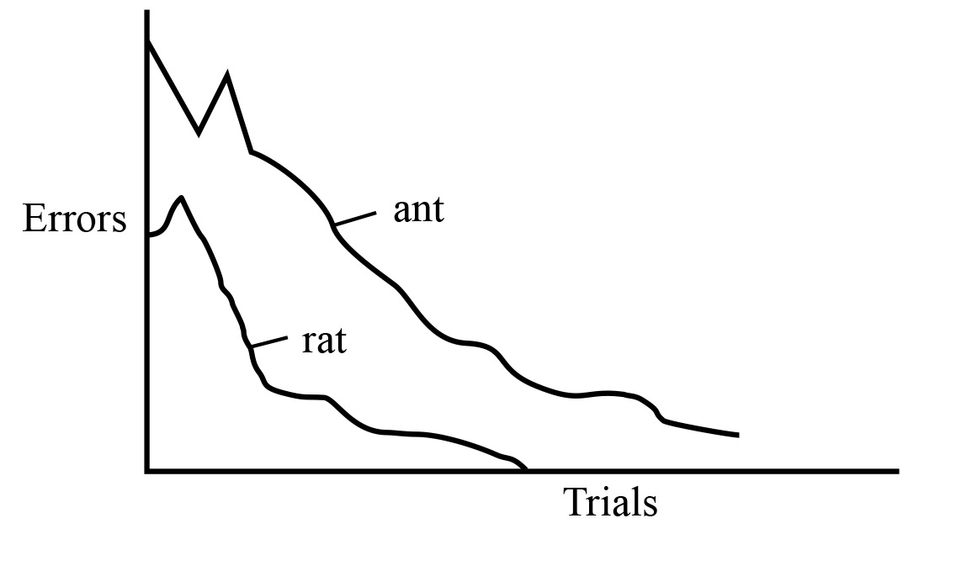
(i) What conclusions about learning in rats and ants are evident from the data? (03 marks)
………………………………………………………………………………………………………………………………………………………………………………………………………………………………………………………………………………………………………………………………………………………………………………………………………………………………………………………………………………………………………………………………………………
(ii) State three factors that could affect the learning of a new situation like a maze in animals. (03 marks)
…………………………………………………………………………………………………………………….…………………………………………………………………………………………………………………………………………………………………………………………………………………………………………………………………………………………………………………………………

44. The pie charts in figure 6 show the relative amounts of types of membrane found in two types of cells

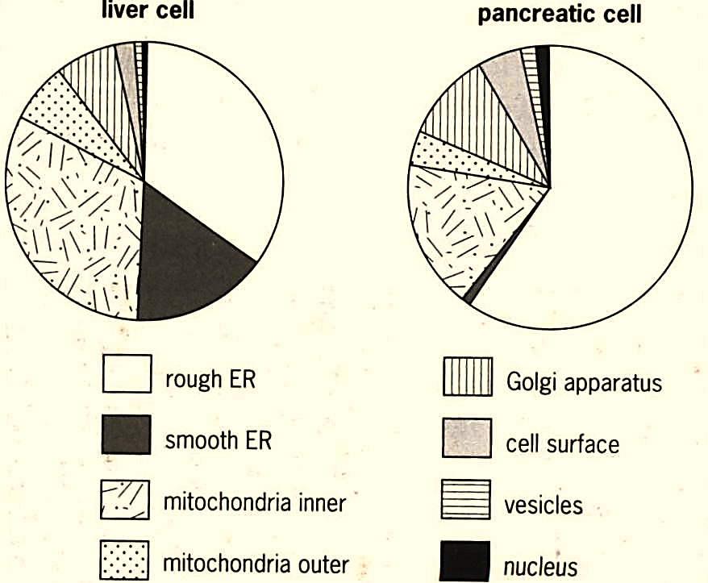
- State which type of membrane is present in the greatest amount in the liver cell (01 mark?)
………………………………………………………………………………………………………………………………………………………………………………………………………………………………………………………………………
b) Compare the relative amounts of membranes in both cells (04 marks)
………………………………………………………………………………………………………………………………………………………………………………………………………………………………………………………………………………………………………………………………………………………………………………………………………………………………………………………………………………………………………………………………………………………………………………………………………………………………………………………………………………………………………………………………………………………………………………………………………………………………………………………………………………………………………………………………………………………………………………………………………………………………………………………………………………………………
c) Using only the data in the pie charts, predict which cell type secretes more protein. Give two reasons for your answer (3 marks)
………………………………………………………………………………………………………………………………………………………………………………………………………………………………………………………………………………………………………………………………………………………………………………………………………………………………………………………………………………………………………………………………………………………………………………………………………………………………………
d) Predict which type of membrane would be present in the largest relative amount in a prokaryote cell (02 marks)
………………………………………………………………………………………………………………………………………………………………………………………………………………………………………………………………………………………………………………………………………………………………
45. a) The diagram shows the appearance of a sarcomere from a relaxed muscle fibril, as seen with a light microscope.

i) Use your knowledge of the sliding filament hypothesis to explain the appearance of each of the bands P, Qand R. (3 marks)
P……………………………………………………………………………………………………………………………………………………………………………
Q……………………………………………………………………………………………………………………………………………………………………………
R………………………………………………………………………………………………………………………………………………………………………
ii) Draw a similar diagram to show the appearance of the sarcomere when the fibril is contracted. ( 2 marks)
………………………………………………………………………………………………………………………………………………………………………………………………………………………………………………………………………………………………………………………………………………………………

b) The drawing shows some of the main flight muscles of a locust.

i) What name is used to describe the action of a pair of muscles such as A and B?
( 1 mark)
………………………………………………………………………………………………………………………………………………………………………………
ii) Explain how the action of muscles A and B brings about movement of the wing.
( 4 marks)
…………………………………………………………………………………………………………………………………………………………………………………………………………………………………………………………………………………………………………………………………………………………………………………………………………………
46. a) Serotonin is a neurotransmitter which is produced by certain neurones in the brain. One of its effects is to increase the activity of sensory neurones in the brain. It also usually improves a person’s mood and keeps them awake. the diagram shows a synapse at which serotonin is the neurotransmitter.

i) Explain how the release of the neurotransmitter serotonin, by neurone A would initiate an impulse in neurone B. ( 3 marks)
………………………………………………………………………………………………………………………………………………………………………………………………………………………………………………………………………………………………………………………………………………………………………………………………………………………………………………………………………………………………………………………………………………………………………………………………………………………………………
ii) The serotonin is normally rapidly reabsorbed from the synaptic cleft by 5HT carrier proteins in the presynaptic membrane. Suggest one advantage of rapidly reabsorbing the serotonin. (1 mark)
………………………………………………………………………………………………………………………………………………………………………………………………………………………………………………………………………

- The diagram shows some of the events which occur in a synapse after the arrival of an impulse at the presynaptic membrane.

B

i) Put the events 1-6 on the diagram in the correct sequence. (3 marks)
………………………………………………………………………………………………………………………………………………………………………………………………………………………………………………………………………………………………………………………………………………………………………………………………………………………………………………………
b) Name the ions labelled A and B. (2 marks)
………………………………………………………………………………………………………………………………………………………………………………………………………………………………………………………………………
c) Name one transmitter molecule released by synaptic vesicles. (1 marks)
………………………………………………………………………………………………………………………………………………………………………………

END

